Semester One Examination, 2013

Question/Answer Booklet 1



CHEMISTRY 3AB

Student name: _______________________________________________________________

Teacher: _______________________________________________________________

Time allowed for this paper
Reading time before commencing work: ten (10) minutes
Working time for paper: three (3) hours

Materials required/recommended for this paper
To be provided by the supervisor
Three (3) Question/Answer booklets
Multiple-choice Answer Sheet attached to Booklet 3
Chemistry Data sheet

To be provided by the candidate
Standard items: pens, pencils, eraser, correction fluid/tape, ruler, highlighters
Special items: non-programmable calculators satisfying the conditions set by the School Curriculum and Standards Authority for this course

Important note to candidates
No other items may be taken into the examination room. It is your responsibility to ensure that you do not have any unauthorised notes or other items of a non-personal nature in the examination room. If you have any unauthorised material with you, hand it to the supervisor before reading any further.
Structure of this paper

Section | Number of questions available |  | Number of questions to  be answered | Suggested  working time  (minutes) |  | Marks  available | Percentage  of exam
Section One:  Multiple-choice | 25 |  | 25 | 50 |  | 25 | 25
Section Two:  Short answer | 11 |  | 11 | 60 |  | 70 | 35
Section Three:  Extended answer | 6 |  | 6 | 70 |  | 80 | 40
 |  |  |  | Total | 175 |  | 100

Instructions to candidates

1. Write your name and your teacher’s name on all three (3) booklets.

2. The rules for the conduct of Western Australian external examinations are detailed in the Student Information Handbook 2013. Sitting this examination implies that you agree to abide by these rules.

2. Answer the questions according to the following instructions.

Section One: Answer all questions on the Multiple-choice answer sheet attached to the front of Booklet 3. Marks will not be deducted for incorrect answers. No marks will be given if more than one answer is completed for any question.

Sections Two and Three: Write your answers in the Question/Answer Booklets provided.

3. When calculating numerical answers, show your working or reasoning clearly unless instructed otherwise.

4. You must be careful to confine your responses to the specific questions asked and to follow any instructions that are specific to a particular question.

5. Spare pages are included at the end of all Booklets. They can be used for planning your responses and/or as additional space if required to continue an answer.
- Planning: If you use the spare pages in planning, indicate this clearly at the top of the page.
- Continuing an answer: If you need to use the space to continue an answer, indicate in the original answer space where the answer is continued, i.e. give the page number.
Fill in the number of question(s) that you are continuing to answer at the top of the page.
Section One: Multiple-choice 25% (50 marks)

This section has 25 questions. Answer all questions on the separate Multiple-choice Answer Sheet provided. Marks will not be deducted for incorrect answers. No marks will be given if more than one answer is completed for any question.

Suggested working time: 50 minutes.

1. Which of the following correctly lists the elements in the order of increasing radius?
(A) Br < Se < As < Ge
(B) Ge < As < Se < Br
(C) As < Se < Br < Ge
(D) Se > Br > Ge < As

2. The first four successive ionisation energies for element X are
0.637 MJmol⁻¹ 1.24 MJmol⁻¹ 2.41 MJmol⁻¹ 7.12 MJmol⁻¹
Which of the following formulae is most likely for the oxide of element X?
(A) XO
(B) X₂O
(C) XO₃
(D) X₂O₃

3. Which one of the following statements about Group 17 elements is true?
(A) The radius of chloride ion is larger than that of the iodide ion.
(B) The boiling point of liquid bromine (Br₂) is higher than that of liquid fluorine (F₂).
(C) An iodine atom is more electronegative than a chlorine atom.
(D) The first ionisation energy of bromine is higher than that of fluorine.

4. The x-axis of the graph below represents the atomic number of the elements in period 3.
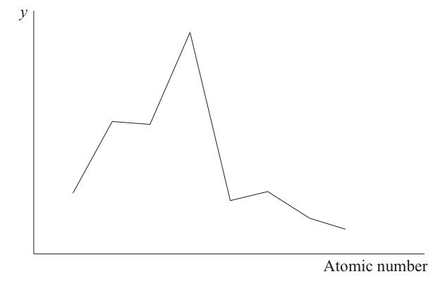
Which variable could represent the y-axis?
(A) Melting point
(B) Electronegativity
(C) Ionisation energy
(D) Atomic radius

5. Which statements about the periodic table are correct?
I. The elements Mg, Ca and Sr have similar chemical properties.
II. Elements in the same period have the same number of electron shells.
III. The oxides of Na, Mg and P are basic.

(A) I and II only
(B) I and III only
(C) II and III only
(D) I, II and III

6. Which of the following describes the nature of the covalent bonds and shape of the OF₂ molecule?
(A) non-polar and linear
(B) polar and bent
(C) non-polar and bent
(D) polar and linear

7. Which of the following statements is not true of van der Waals’ forces?
(A) They are all intermolecular interactions.
(B) They include dispersion forces which are of significance between non-polar molecules in both the liquid and solid phase.
(C) They are not significant in covalent network substances since covalent bonding is much stronger than van der Waals forces.
(D) They account for the stability of nitrogen gas molecules (N₂) which can not be broken down into separate nitrogen atoms even at high temperature.

8. In which of the following liquids would you expect hydrogen bonding to be present between their molecules
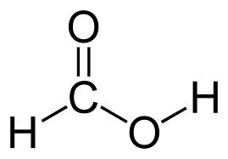
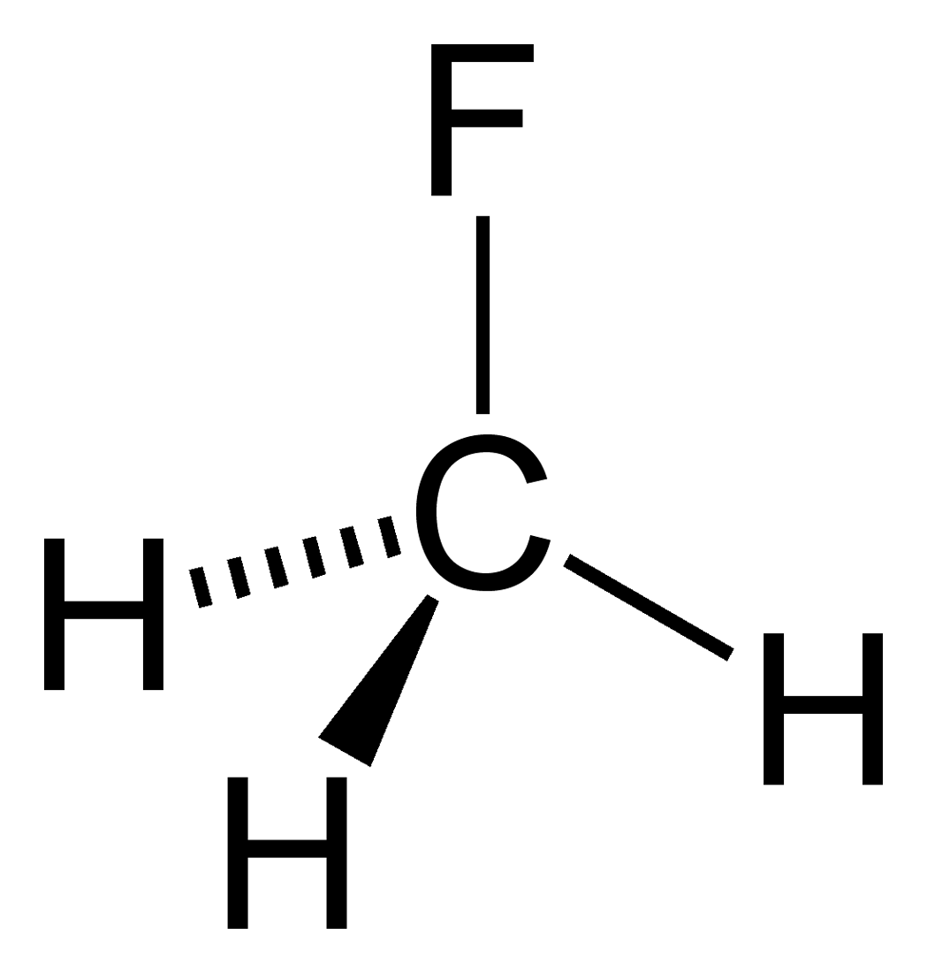
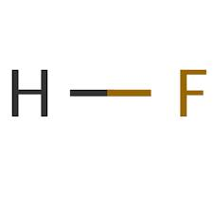

Hydrogen fluoride Methanoic acid Fluoromethane
(A) hydrogen fluoride and methanoic acid only
(B) hydrogen fluoride and fluoromethane only
(C) all of them
(D) hydrogen fluoride only

9. The equation for an equilibrium system involving hydrogen iodide is as follows

2HI_{(g)}  H_{2(g)} + I_{2(g)} ∆H = -51.8 kJ mol⁻¹

Which of the following changes would cause the rate of formation of products to increase?

- Increasing the concentration of H₂.
- Increasing the concentration of HI
- Increasing the volume of the system without changing the amount of substance present.
- Increasing the temperature.

(A) II and IV only
(B) II and III and IV only
(C) II and III only
(D) I, II and IV only

10. When chloride ions are added to a solution containing Co(H₂O)₆²⁺_{(aq)}, the following equilibrium is established.
Co(H₂O)₆ ²⁺_{(aq)}   4Cl⁻_{(aq)} ↔ CoCl₄ ²⁻_{(aq)} + 6H₂O_{(l)}
Pink Blue

Which of the following statements about the colour of the solution is true?
(A) Diluting the solution with water will make it turn blue.
(B) If the reaction is exothermic, heating the solution will make it turn blue.
(C) If the reaction is endothermic, cooling the solution will make it turn pink.
(D) Adding a large amount of solid potassium chloride to the solution will make it turn pink.

11. The graph shows the concentrations over time for the system:
CO_{(g)} +  2H_{2(g)} ↔  CH₃OH_{(g)}
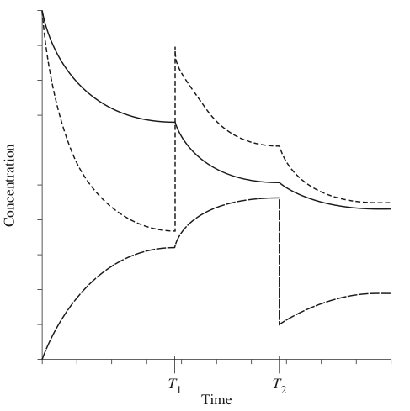
What happens at time T₁ and T₂ ?

 | T₁ | T₂
(A) | H₂ added | CH₃OH removed
(B) | CO added | CH₃OH removed
(C) | H₂ added | CO removed
(D) | CO added | CO and H₂ removed

Questions 12 and 13 refer to the following information.

The graph below refers to the gaseous equilibrium reaction: CO_{2(g)} + H_{2(g)} ↔ CO_{(g)} + H₂O_{(g)}

The effect of increasing pressure and temperature on the yield is shown in the graph below.
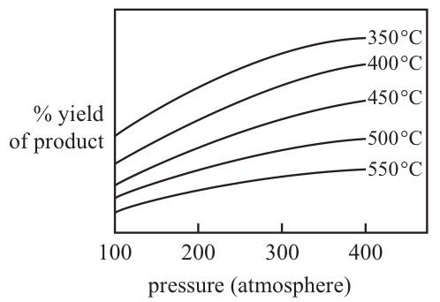

12. Which one of the following statements about the above gaseous reaction is true?
(A) The reaction is endothermic because the yield increases as the temperature increases.
(B) The reaction is exothermic because the yield increases as the temperature increases.
(C) The reaction is exothermic because the yield decreases as the temperature increases.
(D) The reaction is endothermic because the yield decreases as the temperature increases.

13. Which of the following best describes the effect of a catalyst on the reaction above?

 | Effect on the rate of the forward reaction | Effect on the rate of the reverse reaction | Effect on equilibrium
(A) | increase | increase | favours forward reaction
(B) | increase | increase | favours reverse reaction
(C) | increase | increase | no change
(D) | increase | decrease | no change

14. Consider a solution of lead (II) chloride at 25°C in equilibrium with some solid lead (II) chloride at the bottom of the solution.
Pb²⁺_{(aq)} + 2Cl⁻_{(aq)} ↔ PbCl_{2(s)}

Which of the following would be the best way to increase the concentration of the lead and chloride ions in the solution?
(A) Allowing some of the water to evaporate and then leaving the system to reach equilibrium again.
(B) Heating the system to 30°C.
(C) Adding some more solid lead(II) chloride.
(D) Sealing the container and vigorously shaking the solution.
15. Under the conditions used industrially, ethene and steam react as follows

C₂H_{4(g)} + H₂O_{(g)} ↔ C₂H₅OH_{(g)} ΔH = - 46 kJ mol⁻¹

Which set of conditions would give the best yield of ethanol at equilibrium?
(A) High temperature, low pressure
(B) High temperature, high pressure
(C) Low temperature, high pressure
(D) Low temperature, low pressure
16. The following sets of solutions are mixed. In which of these will there be no visible reaction?
(A) Set 1 consisting of barium hydroxide, dilute sulfuric acid, potassium nitrate
(B) Set 2 consisting of potassium phosphate, copper (II) sulfate and sodium chloride
(C) Set 3 consisting of sodium chloride, copper (II) sulfate and silver nitrate
(D) Set 4 consisting of sodium iodide, barium nitrate and potassium hydroxide

17. When charcoal (C) reacts in the presence of oxygen, carbon monoxide and carbon dioxide are produced according to the following chemical reactions:
C_{(s)} +  ½ O_{2(g)} → CO_{(g)}
C_{(s)} + O_{2(g)} → CO_{2(g)}
What would be the total mass of gas produced when 400 g of charcoal is reacted, assuming equal amounts are consumed in each reaction?
(A) 0.93 kg
(B) 1.20 kg
(C) 1.50 kg
(D) 2.50 kg
18. All of the carbon dioxide in a soft drink with an initial mass of 381.04 g was carefully extracted and collected as a gas. The final mass of the drink was 380.41 g.
What volume would the carbon dioxide occupy at 100 kPa and 25°C?
(A) 0.335 L
(B) 0.355 L
(C) 0.565 L
(D) 0.635 L
19. All the lead ions present in a 50.0 mL solution were precipitated by reaction with excess chloride ions. The mass of the dried precipitate was 0.595 g.
What was the concentration of lead in the original solution?
(A) 8.87 g L⁻¹
(B) 10.2 g L⁻¹
(C) 11.9 g L⁻¹
(D) 16.0 g L⁻¹

20. Chromium carbonate is insoluble and precipitates according to the chemical equation below
2 Cr³⁺_{(aq)} + 3 CO₃²⁻_{(aq)}  Cr₂(CO₃)_{3(s)}
A solution containing 0.600 mol of chromium nitrate is added to a solution containing 0.600 mol of sodium carbonate. How much chromium carbonate is precipitated?

(A) 0.200 mol
(B) 0.300 mol
(C) 0.400 mol
(D) 0.600 mol

21. Pure water at 100 °C has a pH of 6.14. This is because
(A) pH measurements at this temperature are unreliable.
(B) pH measurements are affected by the bubbles of hydrogen gas that form in boiling water.
(C) the self-ionisation of water is endothermic.
(D) the concentration of H₃O⁺ ions is not equal to the concentration of OH⁻ ions at this temperature.

22. Which of the following are examples of Lowry-Bronsted acid-base reactions?
I. Mg + 2 H⁺  Mg²⁺ + H₂
II. NH₄⁺ + OH⁻  NH₃ + H₂O
III. NH₂⁻ + H₂O  NH₃ + OH⁻
IV. 3 Cu + 8 H⁺ + 2 NO₃⁻  3 Cu²⁺ + 2 NO + 4 H₂O

(A) I, II and III only
(B) I and II only
(C) II, III only
(D) II, III and IV only
23. A 0.100 molL⁻¹ ethanoic solution is 1.34% ionised at a fixed temperature. The pH of the solution is
(A) 3.41
(B) 2.87
(C) 1.34
(D) 0.870

24. Which of the following equations best represents the chemical reaction between a 0.1 molL⁻¹ sodium hydroxide solution and dilute ethanoic acid solution?
I. CH₃COOH_{(aq)} + OH⁻_{(aq)}  CH₃COO⁻_{(aq)} + H₂O_{(l)}
II. CH₃COOH_{(aq)} + K⁺_{(aq)} + OH⁻_{(aq)}  CH₃COO⁻_{(aq)} + H₂O_{(l)} + K⁺_{(aq)}
III. CH₃COOH_{(aq)} + KOH_{(aq)}  KCH₃COO_{(aq)} + H₂O_{(l)}
IV. H⁺_{(aq)} + OH⁻_{(aq)}  H₂O_{(l)}

(A) Both I and IV are equally correct
(B) Both I and III are equally correct.
(C) I only
(D) IV only

25. A acid-base buffer is a solution that resists change in pH. Which of the following mixtures would make a good buffer solution??
(A) 100.0 mL of 0.10 molL⁻¹ NaHSO₄ solution and 100.0 mL of 0.10 molL⁻¹ Na₂SO₄ solution.
(B) 100.0 mL of 0.10 molL⁻¹ H₂SO₄ solution and 100.0 mL of 0.10 molL⁻¹ NaHSO₄ solution.
(C) 100.0 mL of 0.10 molL⁻¹ NaH₂PO₄ solution and 100.0 mL of 0.10 molL⁻¹ Na₃PO₄ solution.
(D) 100.0 mL of 0.10 molL⁻¹ NH₃ solution and 100.0 mL of 0.10 molL⁻¹ CH₃COOH solution.

END OF MULTIPLE CHOICE SECTION

Section Two: Short answer 35% (70 Marks)
This section has 11 questions. Answer all questions. Write your answers in the spaces provided.
When calculating numerical answers, show your working or reasoning clearly. Express numerical answers to three (3) significant figures and include appropriate units where applicable.
Spare pages are included at the end of this booklet. They can be used for planning your responses and/or as additional space if required to continue an answer.

- Planning: If you use the spare pages for planning, indicate this clearly at the top of the page.
- Continuing an answer: If you need to use the space to continue an answer, indicate in the original answer space where the answer is continued, i.e. give the page number. Fill in the number of the question(s) that you are continuing to answer at the top of the page.

Suggested working time: 60 minutes

Question 26 (11 marks)
(a) Write the electron configuration for each of the species below. (2 marks)

^{Species} | Electron configuration
Sulfide ion

Aluminium atom

(b) Complete the table below
All valence electron pairs should be presented either as : or — (9 marks)

^{Species} | Lewis electron dot diagram | Sketch or name of shape | Polarity of molecule (polar or non-polar)
NBr₃

OBr₂

SO₃

Question 27 (5 marks)
(a) Place each of the following substances in the appropriate column of the table below on the basis of the experimental observation stated in the table below. (2 marks)
{ Br_{2(l)} , Cu_{(s)} , NH₄NO_{2(s)} , Fe_{(s)} }

Conducts electricity well but does not dissolve in dilute hydrochloric acid | Boils at a temperature below 100ºC | Forms a pale green solution when added to a dilute solution of ethanoic acid | Can only conduct electricity in molten/aqueous solution
(b) State the most significant type of intermolecular forces for each of the following liquids. (3 marks)

^{Liquids} | Most significant intermolecular force
Sulfur (S₈)

CH₃F

H₂SO₄

Question 28 (3 marks)

Write ONE relevant ionic chemical equation to explain each of the observations shown in the table below.

Observation | Explanatory equation
The pH of a solution of NaHCO₃ is greater than 7.

The addition of solid NaNH₂ to water produces a pungent odour and turns red litmus paper to blue.

A vinegar smell is produced when a colourless liquid is added to a dilute solution of potassium ethanoate.

Question 29 (5 marks)

Explain the following using relevant concepts and theories.

(a) The first ionization energy of a fluorine atom is higher than that of a boron atom. (3 marks)

_____________________________________________________________________________________

_____________________________________________________________________________________

_____________________________________________________________________________________

_____________________________________________________________________________________

_____________________________________________________________________________________

_____________________________________________________________________________________

_____________________________________________________________________________________

_____________________________________________________________________________________

_____________________________________________________________________________________

_____________________________________________________________________________________

_____________________________________________________________________________________

(b) The radius of a fluoride ion (F⁻) is larger than the radius of sodium ion (Na⁺) even though both have the same number of electrons. (2 marks)

_____________________________________________________________________________________

_____________________________________________________________________________________

_____________________________________________________________________________________

_____________________________________________________________________________________

_____________________________________________________________________________________

_____________________________________________________________________________________

_____________________________________________________________________________________

_____________________________________________________________________________________

_____________________________________________________________________________________

_____________________________________________________________________________________

_____________________________________________________________________________________
END OF BOOKLET 1

Semester One Examination, 2013

Question/Answer Booklet 2


CHEMISTRY 3AB

Student name: _______________________________________________________________

Teacher: _______________________________________________________________

Section Two: Short answer (cont.)

Question 30 (6 marks)

The following diagram shows dipole-dipole interaction in liquid hydrogen chloride.

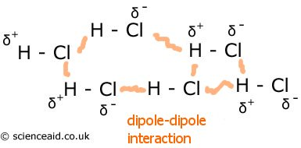

Liquid methanol (CH₃OH) and solid sodium hydroxide (NaOH) are both soluble in water.

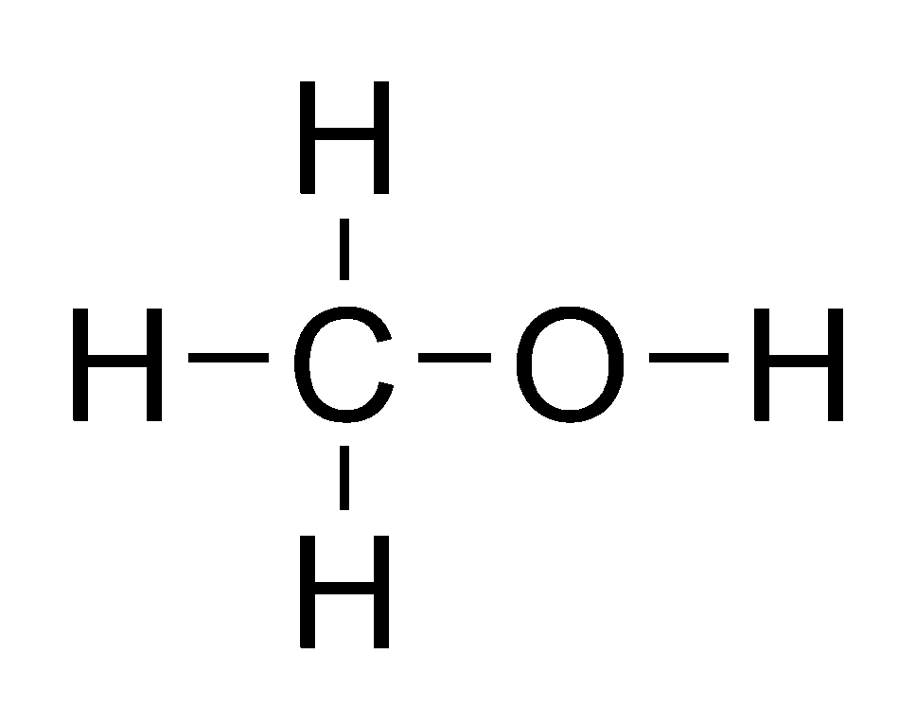
(a) Use the diagram above as a guide to draw relevant diagrams showing the most dominant form of interaction between EACH of the two substances above and liquid water molecules in solution.
(Note: an electron dot diagram for methanol has been provided for your reference) (2 marks)

Electron dot diagram for methanol:

methanol in water | sodium hydroxide in water
Name of interaction: | Name of interaction:

(b) Name the interaction that you have drawn in part (a) in the space provided above. (2 marks)

(c) At atmospheric pressure, methanol has a boiling point of about 65ºC while sodium hydroxide has a boiling point of approximately 1390ºC. Briefly explain this difference using relevant concepts and theories.
(2 marks)

_____________________________________________________________________________________

_____________________________________________________________________________________

_____________________________________________________________________________________

_____________________________________________________________________________________

_____________________________________________________________________________________

_____________________________________________________________________________________

_____________________________________________________________________________________
Question 31 (6 marks)

Propane is a hydrocarbon (C₃H₈) and is sometimes referred to as liquefied petroleum gas, LP-gas, or LPG. It is
used as an alternative fuel to petroleum and diesel.

People use propane in and around their homes for water heaters, outdoor grills, fireplaces, and appliances.
Industrial uses include propane-driven forklifts and fleet vehicles.

The chemical equation for the combustion of propane in air is

C₃H_{8(g)} + 5O_{2(g)} → 3CO_{2(g)} + 4H₂O_{(l)}

(a) Consider the four graphs below showing changes in energy (kJ mol⁻¹) against reaction coordinate

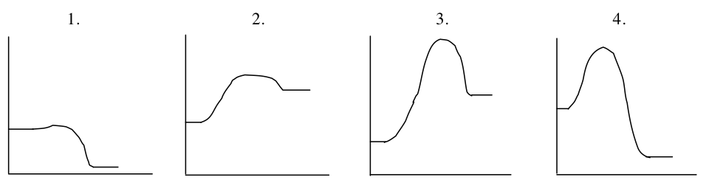
One of these graphs represents the combustion of propane. Identify this graph, giving reasons for your choice. Use lines or markings to clearly show activation energy and heat of reaction on your chosen graph. (4 marks)
___________________________________________________________________________
___________________________________________________________________________
___________________________________________________________________________
___________________________________________________________________________
___________________________________________________________________________
___________________________________________________________________________
___________________________________________________________________________

(b) Identify the graph that represents a process most likely to proceed spontaneously at room temperature. Briefly explain your choice. (2 marks)
___________________________________________________________________________
___________________________________________________________________________
___________________________________________________________________________
___________________________________________________________________________

Question 32 (6 marks)
Consider the following reaction:
Na₂CO_{3(s)} + 2 H⁺_{(aq)} → 2 Na⁺_{(aq)} + CO_{2(g)} + H₂O_{(l)}

In an experiment 0.200 mole of sodium carbonate powder and 0.100 mole of hydrochloric acid were placed in
an open beaker.

The reaction was allowed to proceed to completion.
(a) On the axes below sketch graphs to illustrate the rate of disappearance of the sodium carbonate powder and the hydrochloric acid over time. Also sketch the rate of appearance of the carbon dioxide. Clearly label all three graphs. (3 marks)

Amount in
moles

0.200

0.100

time
(b) On the axes above add a new graph for Na₂CO_{3(s)} (note: use a dotted line -----) showing the effect of using large crystals of sodium carbonate instead of the powder. Explain in terms of the Collision theory why this graph is the shape you have drawn. (3 marks)
___________________________________________________________________________
___________________________________________________________________________
___________________________________________________________________________
___________________________________________________________________________
___________________________________________________________________________
___________________________________________________________________________
___________________________________________________________________________
___________________________________________________________________________
___________________________________________________________________________
___________________________________________________________________________
___________________________________________________________________________

Question 33 (9 marks)
Strontium hydroxide, Sr(OH)₂ is slightly soluble in water. The equilibrium established when solid Sr(OH)₂ is in contact with its saturated solution is represented by
Sr(OH)_{2(s)} ↔ Sr²⁺_{(aq)} + 2OH⁻_{(aq)}
An equilibrium mixture of solid strontium hydroxide and its saturated solution is prepared. Four test tubes are set up, each containing some of the equilibrium mixture – a little white solid under a colourless solution. Each of the test tubes is treated as described below.
Complete the table below by indicating the direction of the expected shift in equilibrium following the changes stated in the table. Use Le Chatelier’s theory to briefly explain how the shift was predicted.

Test tube | Change | Direction of shift in equilibrium (write ‘left’, ‘right’ or no change) | Reasons for shift (or no change)
A | A little solid strontium iodide is added and the mixture shaken
B | A little concentrated hydrochloric acid is added and the mixture shaken
C | A little solid sodium carbonate is added and the mixture shaken

Question 34 (7 marks)

Consider the following process at equilibrium.

CH_{4(g)} + H₂O_{(l)} ↔ 3 H_{2(g)} + CO_{(g)} ΔH = +205 kJ/mol

(a) Predict whether the following changes will increase, decrease or have no effect to the rate at which equilibrium is attained. (3 marks)

Change | Effect
Liquid water is added

The pressure of CH₄ is increased

The temperature is decreased to a new constant value

(b) Predict whether the following changes will increase, decrease or have no effect on the equilibrium yield of the reaction and the value of equilibrium constant (K) (4 marks)

Change | Effect on yield | Effect on equilibrium constant (K)
The system is cooled to a new temperature

Decreasing the volume of the system

Question 35 (6 marks)
Complete the following table below by giving a brief description of a chemical test that could be used to distinguish between the pair of substances listed. State relevant observations relating to the test used for each of substance 1 and substance 2.

^{Substances to be distinguished} |  | Brief description of chemical test (chemical equations are not required) | Observation (write nvr if no visible change is observed)
Substance 1 | Substance 2 |  | Substance 1 | Substance 2
0.5 mol/L sodium sulfate solution | 0.5 mol/L sodium hydroxide solution
solid iron (II) carbonate | solid iron (II) hydroxide
Question 36 (6 marks)

Write balanced ionic equations and observations for each of the following. In each case describe in full what you
would observe, including
- any colours
- odours
- precipitates (give colour)
- gases evolved (give colour or describe as colourless).
If no change is observed, you should state this.
(a) 20.0 mL of 0.5 molL⁻¹ calcium chloride solution is mixed with 100.0 mL of 1.0 molL⁻¹ lead (II) nitrate solution. (3 marks)

^{Equation}
Observation

(b) Solid calcium hydroxide is added to dilute ammonium iodide solution. (3 marks)

^{Equation}
Observation

END OF BOOKLET 2
END OF BOOKLET 2

Semester One Examination, 2013

Question/Answer Booklet 3


CHEMISTRY 3AB

Student name: _______________________________________________________________

Teacher: _______________________________________________________________

For each question, shade the box to indicate your answer.
Use only a blue or black pen to shade the boxes.

For example, if b is your answer: a  b  c  d 

If you make a mistake, place a cross through that square then shade your answer.
Do not erase or use correction fluid.

For example, if b is a mistake and d is your correct answer: a  b  c  d 

If you then want to use your first answer b, cross out d and then circle b.

a  b  c  d 
Marks will not be deducted for incorrect answers.

No marks will be given if more than one answer is completed for any question.
1 | a  b  c  d  |  | 6 | a  b  c  d  |  | 11 | a  b  c  d 
2 | a  b  c  d  |  | 7 | a  b  c  d  |  | 12 | a  b  c  d 
3 | a  b  c  d  |  | 8 | a  b  c  d  |  | 13 | a  b  c  d 
4 | a  b  c  d  |  | 9 | a  b  c  d  |  | 14 | a  b  c  d 
5 | a  b  c  d  |  | 10 | a  b  c  d  |  | 15 | a  b  c  d 

16 | a  b  c  d  |  | 21 | a  b  c  d 
17 | a  b  c  d  |  | 22 | a  b  c  d 
18 | a  b  c  d  |  | 23 | a  b  c  d 
19 | a  b  c  d  |  | 24 | a  b  c  d 
20 | a  b  c  d  |  | 25 | a  b  c  d 

Section Three: Extended answer 40% (80 Marks)
This section contains six (6) questions. You must answer all questions. Write your answers in the spaces provided.
Where questions require an explanation and/or description, marks are awarded for the relevant chemical content and also for coherence and clarity of expression. Lists or dot points are unlikely to gain full marks.
Final answers to calculations should be expressed to three (3) significant figures.
Spare pages are included at the end of this booklet. They can be used for planning your responses and/or as additional space if required to continue an answer.
- Planning: If you use the spare pages for planning, indicate this clearly at the top of the page.
- Continuing an answer: If you need to use the space to continue an answer, indicate in the original answer
space where the answer is continued, i.e. give the page number. Fill in the number of the question(s) that you are continuing to answer at the top of the page.
Suggested working time: 70 minutes ________________________________________________________________________________________

Question 37 (14 marks)

A heater company produces a portable gas heater that can run on either butane gas (C₄H₁₀) cylinders or household supply of natural gas (CH₄).

i. The equation for the complete combustion of butane gas is as follows:

2 C₄H_{10(g)} + 13 O_{2(g)} → 8 CO_{2(g)} + 10 H₂O_{(l)}

In normal use, one gas cylinder containing 500.0g of butane will give exactly 150 hours of use.

ii. The equation for the complete combustion of natural gas is as follows:

CH_{4(g)} + 2 O_{2(g)} → CO_{2(g)} + 2 H₂O_{(l)}

The methane from the household supply system is delivered at 200.0 kPa pressure and at a rate of 2.40 L per hour.

Assume a temperature of 20.0ºC throughout.

(a) Which gas (butane or methane) requires the most mass (in grams) of oxygen per hour to sustain complete combustion of the butane during normal operation? (show all working) (7 marks)

(b) Calculate the mass of water produced during 10.0 hours of normal operation when running on the butane gas cylinders. (2 marks)

On the first of July 2012, the Australian government imposed a carbon tax level of $23.0 per tonne of carbon
dioxide emitted on a number of manufacturing industries (1 tonne = 1 x 10⁶ g).

Like many other industries, this heater company immediately announced a price increase of $5.00 on this portable
heater model to help it ‘pay for the new tax’.

(c) Assuming the heater is operating from a household methane gas system and is used for 100 days a year, calculate the total mass of carbon dioxide produced by this portable heater over a period of 10 years (life expectancy of a heater) and state whether this price increase is fair for the consumers. (5 marks)

Question 38 (13 marks)

The preparation of sulfuric acid from iron pyrites (FeS₂) can be represented by the following series of reactions:

4FeS₂ + 11O₂ → 2Fe₂O₃ + 8SO₂
2SO₂ + O₂ ↔ 2SO₃ (Contact Process)
SO₃ + H₂O → H₂SO₄

(a) How many moles of sulfuric acid would be produced from ONE mole of iron pyrites? (1 mark)

(b) What mass of iron pyrites would be needed to produce 123 tonne (1 tonne = 1 x 10⁶ g) of sulfuric acid if the Contact process only converts 92.5% of the sulfur dioxide and the other reactions achieve 100% conversion? (6 marks)

Sulfurous acid (H₂SO₃) can be produced by the dissolving of sulfur dioxide gas in liquid water under the right
conditions.

SO_{2(g)} + H₂O_{(l)} ↔ H₂SO_{3(aq)} (Reaction 1)

Sulfurous acid partially ionises in solution

H₂SO_{3(aq)} ↔ H⁺_{(aq)} + HSO₃⁻_{(aq)}

HSO₃⁻_{(aq)} ↔ H⁺_{(aq)} + SO₃²⁻_{(aq)}

(c) If Reaction 1 above is slightly exothermic then predict the effect of the following changes on the pH of the solution: (3 marks)

Change to equilibrium | Effect on pH (write increase, decrease or no change)
The temperature of the system is increased to a new constant value

Finely powdered CaCO_{3(s)} is added

A little concentrated nitric acid is added

(d) The equilibrium constant (K) value for the ionisation of a 1.0 molL⁻¹ sulfurous acid solution is 1.40 x 10⁻² at 25ºC and atmospheric pressure and the equilibrium constant value for the ionisation of a 1.0 molL⁻¹ hydrogensulfite (HSO₃⁻) solution is 6.30 x 10⁻⁸ at the same conditions.

Which of these two solutions (sulfurous acid or hydrogen sulfite) would be a stronger electrolyte at 25ºC? Explain your answer. (3 marks)
_____________________________________________________________________________________

_____________________________________________________________________________________

_____________________________________________________________________________________

_____________________________________________________________________________________

_____________________________________________________________________________________

_____________________________________________________________________________________

_____________________________________________________________________________________

_____________________________________________________________________________________

_____________________________________________________________________________________

_____________________________________________________________________________________

_____________________________________________________________________________________

_____________________________________________________________________________________

Question 39 (14 marks)

A local water sample was analysed and found to contain a high concentration of magnesium and calcium ions.

Common identification tests for the presence of these ions include the precipitation reaction of these ions with
sodium hydroxide or sodium carbonate solutions.

(a) Write relevant ionic equations to show the precipitation of magnesium and calcium ions from the water by dilute sodium hydroxide solution. (2 marks)

Equation 1: _________________________________________________________________________

Equation 2: _________________________________________________________________________

(b) Draw a Lewis electron dot diagram for Ca(OH)₂ (1 mark)

(c) A 5.00 mL water sample has a magnesium ion concentration of 12.1 mgL⁻¹ and a calcium ion concentration of 5.01 mgL⁻¹. Calculate the mass of calcium ions and magnesium ions in the water sample.
(2 marks)

A scientist attempts to remove all magnesium and calcium ions from a polluted lake using precipitation reaction. In a small trial, he adds 50.0 g of sodium carbonate decahydrate (Na₂CO₃.10H₂O) to 100.0 L of polluted water.

The relevant chemical equations for the precipitation reactions are as follow:

Mg²⁺_{(aq)} + CO₃²⁻_{(aq)} → MgCO_{3(s)}

Ca²⁺_{(aq)} + CO₃²⁻_{(aq)} → CaCO_{3(s)}

The polluted water from the lake was found to contain 2.50 g of calcium ions and 1.50 g of magnesium ions.

(d) Calculate the amount of carbonate ions required to remove all the calcium and magnesium ions from the water and hence determine whether the use of 50.0 g sodium carbonate decahydrate is enough for the total removal of these ions. (6 marks)

(e) From your answer to part (d),

- if the amount of sodium carbonate decahydrate is not enough, determine the mass of additional sodium carbonate decahydrate that needs to be added.

OR

- if the amount of sodium carbonate decahydrate is in excess, determine the mass of unreacted sodium carbonate decahydrate. (2 marks)

Question 40 (15 marks)
Both perchloric acid, HClO₄ and barium hydroxide, Ba(OH)₂ are substances that fully ionise/dissociate when in water solution.
(a) Calculate the pH of a 50.0 mL solution of 0.0250 molL⁻¹ perchloric acid. (1 mark)

(b) Calculate the pH of a 0.0250 molL⁻¹ solution of barium hydroxide. (3 marks)

(c) In an experiment, a student dissolves 0.215 g of solid Ba(OH)₂ in 50.0 mL of 0.025 molL⁻¹ perchloric acid. Calculate the final pH of the mixture. (6 marks)

(d) Assuming the mass of 1.00 L of the final solution mixture is 1.02 kg, determine the concentration of barium ions (in parts per million) at the end of the reaction. (2 marks)

The Arrhenius equation for the ionisation of perchloric acid in water is as follows:
HClO_{4(aq)}  H⁺_{(aq)} + ClO₄⁻_{(aq)}
(e) What would be the expected colour of universal indicator in a solution mixture containing 10.0 mL of 0.105 mol/L perchloric acid (HClO₄) and 10.0 mL of 0.105 mol/L ammonia? Explain using a suitable Lowry-Bronsted equation. (2 marks)
Colour: ____________________________________________________________________________
Equation: ____________________________________________________________________________

(f) Would you expect a 1.0 molL⁻¹ solution of HClO₄ to be a stronger or weaker electrolyte than a 1.0 molL⁻¹ solution of CH₃COOH? Explain. (2 marks)

_____________________________________________________________________________________

_____________________________________________________________________________________

_____________________________________________________________________________________

_____________________________________________________________________________________

_____________________________________________________________________________________

_____________________________________________________________________________________

_____________________________________________________________________________________

_____________________________________________________________________________________

_____________________________________________________________________________________

_____________________________________________________________________________________

Question 41 (17 marks)

Common chemicals used to control algae and bacterial growth in swimming pools include hypochlorous acid HClO and the hypochlorite ion ClO –.

The equilibrium chemical equation between HClO and ClO – ion in water is

H₂O_{(l)} + HClO _{(aq)} ↔ H₃O⁺_{(aq)} + ClO –_{(aq)}

The equilibrium is pH dependent and is very sensitive in the range of pH 7 to 8.
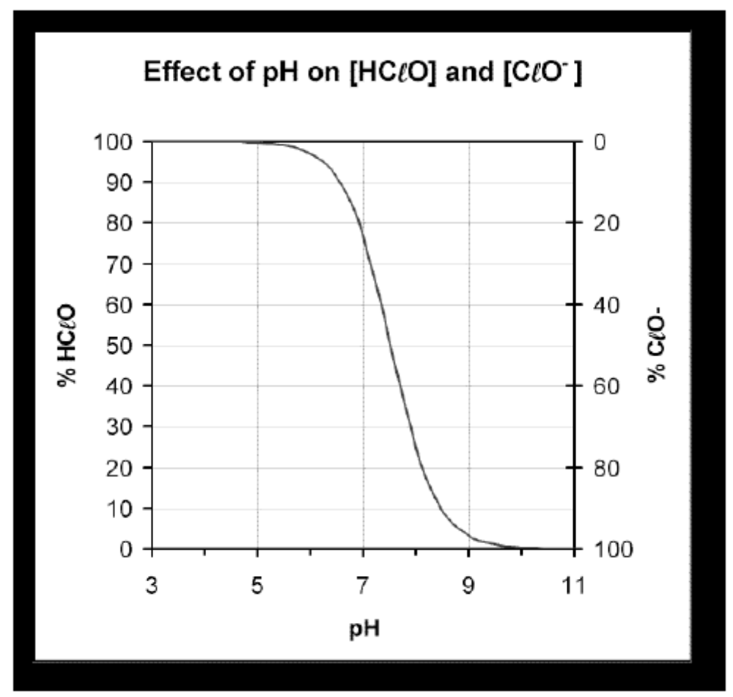

(a) Examine the graph above and state the effect of pH on the concentration of HClO_{(aq)} and ClO⁻_{(aq)} ions.
(1 mark)

_____________________________________________________________________________________

_____________________________________________________________________________________

_____________________________________________________________________________________

(b) State the pH at which the concentration of HClO_{(aq)} equals the concentration of ClO⁻_{(aq)} . (1 mark)

_____________________________________________________________________________________

(c) Use Le Chatelier’s principle to help explain the shape of the graph. Include in your explanation the effect of low and high pH on i. the position of equilibrium and

ii. the concentration of HClO and ClO⁻. (4 marks)
_____________________________________________________________________________________

_____________________________________________________________________________________

_____________________________________________________________________________________

_____________________________________________________________________________________

_____________________________________________________________________________________

_____________________________________________________________________________________

_____________________________________________________________________________________

_____________________________________________________________________________________

_____________________________________________________________________________________

_____________________________________________________________________________________

_____________________________________________________________________________________

_____________________________________________________________________________________

_____________________________________________________________________________________

_____________________________________________________________________________________

_____________________________________________________________________________________

_____________________________________________________________________________________

_____________________________________________________________________________________

_____________________________________________________________________________________

_____________________________________________________________________________________

_____________________________________________________________________________________

_____________________________________________________________________________________

_____________________________________________________________________________________

(d) Write the equilibrium expression (K) for the reaction: H₂O_{(l)} + HClO _{(aq)} ↔ H₃O⁺_{(aq)} + ClO⁻_{(aq)} (1 mark)

(e) The equilibrium constant (K) value for the reaction: H₂O_{(l)} + HClO _{(aq)} ↔ H₃O⁺_{(aq)} + ClO –_{(aq)}
is 3.5 x 10^{–8} at 25ºC. Would you expect the concentration of HClO to be greater, smaller or the same as the concentration of ClO⁻ ions at 25ºC? Explain your answer. (2 marks)

_____________________________________________________________________________________

_____________________________________________________________________________________

_____________________________________________________________________________________

_____________________________________________________________________________________

_____________________________________________________________________________________

_____________________________________________________________________________________

_____________________________________________________________________________________

_____________________________________________________________________________________

_____________________________________________________________________________________

_____________________________________________________________________________________

Ammonia compounds and organic matter enter a swimming pool from many sources. Swimmers and bathers are major contributors with their bodies giving off saliva, sweat, urine and faecal matter.

The removal of ammonia via chemical reaction with HClO to form chloramine (NH₂Cl) is thus very important:

NH_{3(aq)} + HClO_{(aq)} → NH₂Cl _{(aq)} + H₂O_{(l)}

Chloramine is mildly toxic to bacteria, but tends to be irritating to eyes and skin, so it is an unwelcome addition to the pool. Fortunately, chloramine reacts with each other, as

NH₂Cl_{(aq)} + NH₂Cl_{(aq)} → N_{2(g)} + 3 HCl _{(aq)}

(f) An Olympic swimming pool was analysed for ammonia in the water and found to have an ammonia level of 0.175 mg/L. If the swimming pool contains 2,500,000 litres of water then determine the number of moles of hydrochloric acid produced from the reactions above. (2 marks)

(g) Hydrochloric acid can lower the pH of the water in swimming pools. Water with low pH will dissolve plaster and grout in swimming pools and corrode metal products.

Sodium hydrogencarbonate (NaHCO₃) or sodium carbonate (Na₂CO₃) powder is often used to remove the hydrochloric acid that lowers the pH of swimming pools and spas.

The unbalanced equation for the reaction between sodium carbonate and hydrochloric acid is:

Na₂CO_{3(s)} + H⁺_{(aq)} → H₂O_{(l)} + CO_{2 (g)} + Na⁺_{(aq)}

In a swimming pool water testing procedure, a technician recorded a pH reading of 6.50 for a swimming pool containing 2,500,000 litres of water. In order to return the water back to neutral (i.e. a pH reading of exactly 7), he added 44.1 g of 95.0% pure sodium carbonate (Na₂CO₃) to the swimming pool.

Carry out necessary calculations to determine whether the added amount of Na₂CO₃ was able to achieve the desired result (i.e. a final water pH of 7). (6 marks)

Question 42 (7 marks)
Christine buys some balloons to fill with helium (He) for a party. To stop them floating away, she decides to tie small metal rings to each balloon.

The following information is relevant to the questions that follow.

Mass of a balloon = 3.60 g
Mass of string tied to each balloon = 1.50 g
Mass of each metal ring = 1.20 g
Volume of balloon when inflated = 15.0 L
Pressure of gas in inflated balloon: = 103 kPa
Temperature = 25.0° C
(a) Determine the maximum number of moles of gas that can be held by the balloon at the conditions stated above. (1 mark)

(b) Calculate the minimum number of metal rings she will need to tie to each balloon to stop it floating away.
Useful information:
i. The balloon will float upwards if the total mass of the balloon, string, metal rings and the helium gas inside the balloon is less than the mass of air (and nothing else!) removed from a fully inflated balloon.

ii. One (1) mole of air has a mass of 28.8 grams. (6 marks)

END OF PAPER

